Digital History Practice and Reflection in the Dunhuang in Motion Project
My main gains this semester were learning about digital history, learning to use digital tools, and changing my understanding of digital history through practice. Dunhuang, in Motion applies this learning to a question about Dunhuang manuscripts: after they left the Library Cave, through whose hands did they pass, and how did they become collections that can now be searched, read and studied? The project began with a Gephi network as its main output. I later added a QGIS route map and brought them together in a website with English and Chinese versions. The early circulation and scholarly activities mainly cover 1900–1910, while present-day collections and preservation are discussed separately. I organised connections among people, manuscripts and institutions around the movement and study of the manuscripts.
This essay explains how the project developed and changed. It focuses on why I chose networks and maps, how I turned source material into usable data, and how these outputs became part of the website. I initially built the website to display the results. After creating the first version, I invited several people to try it and revised it in response to their questions. I then began to see it as a platform for sharing knowledge, where people unfamiliar with Dunhuang manuscripts could start learning and finding sources. My understanding of digital history developed through specific decisions: what a line should represent, how precisely a date or location can be established, and how readers can understand a visualisation and find its evidence. These questions also became my criteria for evaluating the project.

Choosing Gephi to Examine Connections among People
I initially chose Gephi because the accounts of Dunhuang manuscript circulation that I had encountered usually focused on routes and present locations. They less often brought together the relationships among the people involved. If only the Library Cave and today's collecting institutions are listed, the manuscripts seem to have travelled directly from Dunhuang to London, Paris or Beijing. The people who kept, translated, negotiated over, transported and organised them can easily disappear from the account. I wanted to bring people mentioned in different sources into one view and examine the activities that connected them. Gephi could organise these people and connections into a network that I could expand and correct as I read. It also offered a way to show the different participants involved with the same group of manuscripts.
At first, I mainly expected Gephi to draw relationships among people. Using it showed me that a graph's ability to explain something depends first on how its input tables record relationships. The software can read nodes and edges, but it cannot decide whether knowing someone, participating in an activity and acquiring manuscripts should belong to the same category. Two people appearing in the same article does not establish direct contact between them. I therefore needed to identify specific actions in the sources before deciding what to include in the network, rather than connecting every name I had collected.
I first used Excel to organise the material. I assigned separate identifiers to people, institutions, events and manuscript or document objects. The relationship table recorded the source, target, role and evidence identifier, and linked these to the source table. Different forms of the same name needed to be standardised, while a person's roles in different events needed to remain distinct. Before placing a record in the Source and Target fields, I had to decide whether its arrow represented a manuscript transfer, participation in an activity or the creation of a record. This took more thought than adjusting colours, but it determined whether the network could be interpreted.
While organising my literature review notes, I noticed that Stein acquired Dunhuang manuscripts before Pelliot, but some of these movements became known to Chinese contemporaries only later (Pan, 2025, pp. 135–136). I could not equate detailed surviving reports with the public availability of information at the time. I needed to distinguish when manuscripts moved from when news of them spread. Examining relationships among people also required attention to connections obscured in early accounts.
Gephi is useful for organising relationship records, making comparisons and raising questions. Close reading remains more suitable for examining wording, motives and silences. At present, the project is closer to relationship mapping and exploratory visualisation. It does not yet justify claiming that network measures have verified a structure of intermediaries. I therefore prioritised checking the basis of each node and edge over increasing their number.
When people, events, collections and documents share one network, the number of connections does not have the same meaning for each type. An event may stand out because it has many participants, but this does not make it more important than a transfer handled by only two people. Connecting people to documents through events can preserve the context of their actions. Before calculating further measures, however, I would need to establish which nodes and relationships can be compared.

From a Single Edge to Specific Events
Comments from my instructor and classmates changed how I expanded the network. Xuanying asked how readers could distinguish an agreement, an actual removal and institutional custody when several records appeared as one connection. Yihan reminded me that intermediaries include custodians, translators, officials and staff, whose work and power differed. My instructor further emphasised relationship types and metadata, and recognised that event identifiers could make the same data usable for analyses beyond the network. These comments helped me see that the simplicity of the first graph also concealed the process.
I then focused on events and participants' roles, using stable identifiers to connect people, activities, objects and evidence. An activity may involve a requester, someone carrying it out and the manuscripts concerned. Its arrows must be read together with these specific roles. This is more complicated than drawing a direct link between Stein and Pelliot, but it avoids suggesting that every connection represents manuscripts changing hands. I also gradually separated physical circulation from knowledge transmission. The former concerns acquisition, transport and receipt; the latter concerns examination, photography, correspondence, cataloguing and publication. The two layers use corresponding identifiers, making it easier to trace the research activities involving the same objects after their movement.
The inspection memorandum of 1910 provides a relatively clear example. Volume 2 of Serindia includes a relevant account that allows Stein's request, Pelliot's role in writing, the Chinese manuscripts examined in London and the resulting document to be recorded separately (Stein, 1921, pp. 916–917). Figure 1 shows an extract from the Excel relationship table: N005 is Stein, N012 is Pelliot, B0010 is the manuscripts concerned, KE007 is the activity that produced the memorandum, and W001 is the resulting document. All four relationships point to evidence EV046, but their roles differ. This allows the website to explain what each person did, rather than simply showing that two people were connected. I did not use this account to assign a precise drafting location or a more certain completion date than the source supports.
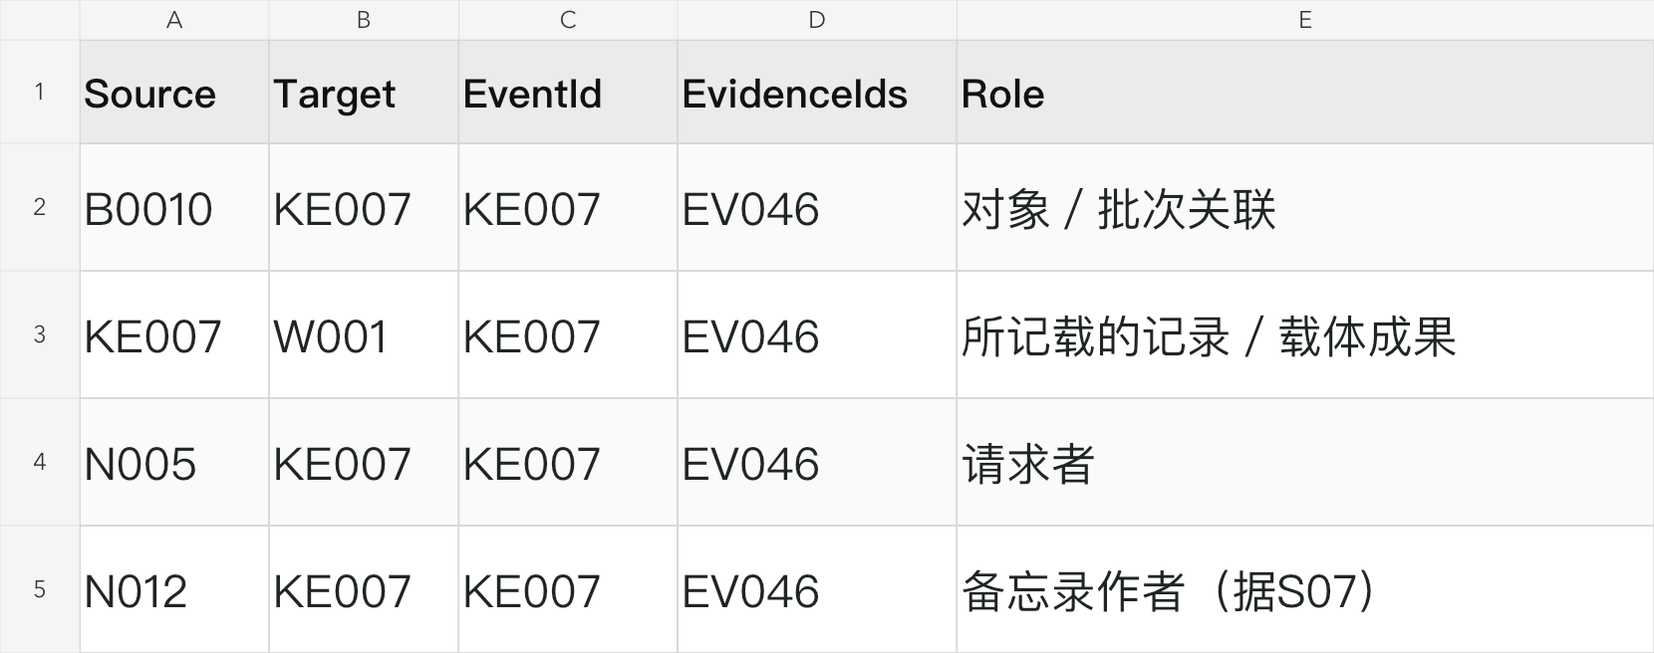
Figure 1. Roles and Evidence in the Gephi Relationship Table
Source: My workbook “敦煌传播网络_最终展示数据_132节点157关系”, sheet “02_Gephi关系”, rows 51–54, selected columns A, B, H, I and O. Original values are unchanged; the fields have been reformatted for the figure.
Later reading in Chinese added connections among Chinese scholars. Qin's (2018) study of the Beijing banquet, access to manuscripts and correspondence about publication allowed me to present the activities of Dong Kang, Luo Zhenyu, Wang Guowei and others more specifically. For example, a jointly signed letter sent in late 1909 and a reply that arrived around 1910 support a correspondence relationship, but do not directly prove that publication had been completed. Jin Shaocheng's request to view a collection also cannot be coded as an actual visit. These distinctions made me pay more attention to verbs, rather than simply collecting names.
The supplementary version expanded the Gephi export of 122 nodes and 136 relationships to 132 nodes and 157 relationships. Among the six added activity records, some accounts of viewing manuscripts may overlap with existing activities, so they cannot be treated as six independent events. I kept the original export and supplementary data separately. The positions of the additions remain provisional, and I have not recalculated centrality for the whole graph. The larger counts only show that the scope of the data has expanded. What matters more is explaining which relationship judgements the new evidence changed.
Recording the two layers separately helped me see the connections between circulation and research. Photography, listing and examination could make manuscript contents known to more people without moving the originals. Nor did organisation and dissemination automatically follow when originals entered an institution. Geographical destinations are therefore only part of the project. It is also necessary to explain who could access, describe and publish the manuscripts.

How Source Selection Shapes Historical Interpretation
There are already well-developed digital resources for Dunhuang manuscripts. The International Dunhuang Programme (IDP) brings together manuscript images, related materials and learning resources from partner institutions, making dispersed collections easier to consult (International Dunhuang Programme, n.d.). These resources provided a foundation for my project and helped me focus on connections among people, activities and routes within the selected period.
When I first collected literature, I was easily drawn to materials with relevant titles that I could download. I later found that general introductions to Dunhuang were useful for background, but did not necessarily answer who did what and when. I began looking for studies that could support particular relationships through identifiable pages, documents and objects, and comparing them with Chinese scholarship I already had, expedition reports and institutional sources. My selection criterion gradually changed from whether a work discussed Dunhuang to which record it could support. The resulting tables served both as import data and as a record of the material behind my judgements.
Obtaining a full text does not mean that I have checked the originals it uses. I encountered some diaries, letters and archival documents used by Qin and Pan through citations in their articles. I could check the researchers' discussions and printed page numbers, but I did not independently examine every original image. The records therefore need to distinguish participants' accounts, later scholarship, transcriptions and researchers' inferences, and indicate which level I actually consulted. Several articles citing the same letter cannot simply be counted as independent pieces of evidence.
Peer feedback identified an imbalance between the sources for Stein's route and the Qing government's route to Beijing. A detailed report can be divided into many actions, while a brief account may not allow this. Directly comparing edge counts could turn differences in source coverage into apparent differences in the scale of historical activity. Further checking improved the records of transport to Beijing and receipt there, and corrected my early summary that there were only orders and no actions. Some handovers and dates remain unclear, however, and cannot be filled in simply to complete a route.
When evidence for a stage is missing, I now state what is missing and what the current basis is, rather than creating a speculative node. Pan's (2025) examination of early dispersal also drew my attention to the different times at which an action occurred, became known and was later described. Compressing them into one date would amplify the error in both the network and the map. A person does not lose historical significance because limited sources leave them outside the graph. The graph's boundaries should show how far my work has reached.
Neat categories should not erase the wording of the sources. Agreement, purchase, removal and “rescue” operate at different levels of interpretation: “rescue” may express a narrator's justification of an action. My tables therefore retain both the original terms and my analytical categories, so readers can distinguish the sources' language from my coding. Using relatively neutral categories does not mean avoiding the colonial context or differences in power. Distinguishing actions from their justification instead provides a better basis for discussing these differences.
Units of quantity can also conceal judgements. Bundles, scrolls, fragments, shelfmarks and transfer records are not interchangeable. Terzi and Whitfield (2024, pp. 56–59) distinguish Stein's different recording systems and attempt to reconstruct the contents of some bundles, while making clear that this cannot recover their original arrangement inside the cave. This helped me recognise that documenting the limits of reconstruction is itself part of research. Converting different units into one number to standardise a table may make the data easier to compare, but it removes their reliable historical meaning.
Organising the tables gave me a more concrete understanding of how source analysis relates to tool use. Merging two forms of a name affects whether two records refer to one person. Splitting an event affects how many relationships appear in the network. To avoid inconsistent decisions, I kept checking notes in the remarks and evidence tables and returned to the original records when adding material. The research question changed too. I first asked how manuscripts were transported away, but later also needed to explain how news, photographs and research outputs gave more people access to them.

Rethinking Routes through QGIS
While organising the network, I found that it could show who participated in circulation, but could not easily show when manuscripts passed through particular places. My instructor's suggestion to add a route map, together with Yihan's map of changes in the placement of guard posts, encouraged me to consider spatial representation. I chose QGIS because it could organise places and routes in layers and connect place names, coordinates and events in the tables. The map shows the sequence of times and places, while the network explains who handled the manuscripts and what happened. Together, they can present the circulation process more clearly. They also prompted me to recheck the correspondence between places and events.
I first organised places, coordinates, event identifiers and route segments in Excel. I then imported reference points and schematic lines into QGIS, using layers, colours, labels and arrows to distinguish routes and knowledge connections. Figure 2 shows the relevant data. The place table distinguishes Dunhuang city, the Mogao Caves site and Cave 17. The schematic line table records sources, targets, time evidence and corresponding events. Different activities can occur at one place, and one event can involve several movements, so a place row cannot simply be equated with one transfer. After importing the data, I checked variant place names, what the coordinates represented, and whether arrow directions matched the recorded sequence.
The arrival of Pelliot-related material in Paris in 1909 and the entry of manuscripts into the library's manuscript department in 1910 are two different dates. Similarly, storage at an institution does not necessarily mean formal accession. The map required me to address these distinctions rather than retain vague descriptions. White (2010, p. 6) emphasises that spatial visualisation can generate questions rather than merely illustrate existing findings. For me, this methodological value appeared when drawing a line exposed an unclear account and sent me back to the sources.
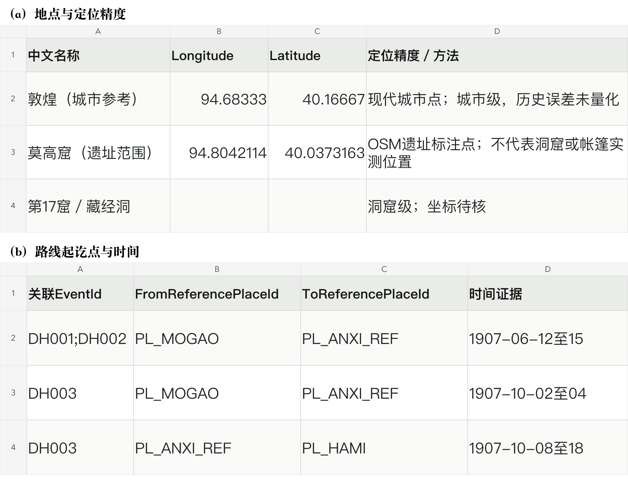
Figure 2. Location Precision and Route Dates in the QGIS Data
Source: My route map workbook, sheets “03_地点与坐标” and “14_示意线导入”, selected columns from rows 2–4. Original values are unchanged; the fields have been reformatted for the figure. Blank coordinates remain unverified.
In Figure 2, the coordinates for Cave 17 remain blank, while the Mogao Caves are represented by a reference point for the site. This preserves the distinction between levels of location precision. A city reference point is not the address of a historical storeroom, and a line between two places is not a reconstructed road. My sources cannot continuously reconstruct the full journey of every manuscript, so I describe these lines as schematic connections between recorded places. The modern basemap also cannot directly represent the political geography of 1900. I have not used it to analyse exact distances, transport speeds or the causal effects of borders on transfers.
Chronological playback helps readers identify the sequence, but can also suggest a continuous and complete journey. An approximate year does not become an exact date simply because it enters a playback function, and a document's date is not necessarily the date of every action it describes. Playback therefore needs accompanying record notes. Where intermediate locations are uncertain, I retain schematic connections rather than add stops along modern roads.
The original QGIS regional map and the website's animated routes are related but distinct outputs. The former is the geographical representation I created. The latter uses the organised records and website code to support playback and consultation, and includes information checked later. Bringing them together allows readers to see the overall direction of circulation before examining the date and source of a particular connection. Calling the whole animation a “QGIS analysis result” would overstate the software's role. I therefore explain separately what the map organises, what interaction adds and which analyses have not been conducted.

From Displaying Outputs to Building a Readable Website
The interactive network shown in class gave me the idea. I wanted readers to be able to search for people, click nodes and examine specific relationships on the website. Initially, I kept adding functions, assuming that more interaction would mean greater participation. The feedback I actually received described a confusing arrangement of information, small text and a lack of clear emphasis.
The problems reported by users showed me that complete data and clear content are different things. Theibault's (2013, p. 174) discussion of information density and transparency in visualisation helps explain this difficulty: information may remain on the page without readers knowing how to interpret it. I enlarged the body text and labels, reordered the sections and placed relationship explanations near the network. Colouring nodes by type and adding a legend only provide a starting point. Readers also need a specific case to understand why these people and events are brought together.
StoryMaps' combination of maps, images and text gave me ideas for organising the website. I drew on its chapters, balance of text and images, and scrolling approach, rather than moving the project directly onto the StoryMaps platform. The website proceeds through manuscript circulation, knowledge transmission and present-day collections, followed by sources and discussion. This order lets readers first learn where the objects went, then who examined and organised them, and finally look up particular collections. It gives the map and network context and avoids filling the homepage with software and file names.
During revision, I invited several people who had not read about Dunhuang manuscripts, or knew little about this history, to try the website. Their comments on reading order, text size and interaction meant that I could no longer arrange the pages around my own familiarity with the material. To reduce clicking, I once presented more content as directly readable cases, but this made the full Gephi network easy to treat as optional. When I emphasised the outputs again, the page began to look like a display of tools. I eventually kept both outputs directly visible within the main reading sequence, with short explanations of their use, while allowing readers to search and consult records themselves. I want to share knowledge with people from different backgrounds, not only classmates already familiar with Dunhuang studies.
Case explanations therefore no longer depend entirely on users clicking a particular node. Text on the Beijing scholars' contacts, the inspection memorandum and cataloguing in London directly identifies people, roles and sources, and then offers a way to locate them in the full graph. The organising work of Lorimer and others also reminds me that making manuscripts into researchable collections involved unpacking, recording and classifying them. Expedition leaders cannot be treated as the only actors (Wang, 1998). Some of this work concerned the broader Stein collections, however, so I need to state its scope rather than equate all of it with Dunhuang manuscripts.
The telegram between Beijing and Lanzhou also connects the two views. Spatially, it has a place of sending and an intended destination. Relationally, it involves a request and institutional contact. The request in the document cannot directly establish when the recipient received it or acted on it. Placing it beside the route narrative and comparing it with activity records explains how the two views complement each other more effectively than showing the map and network separately. It also reminds me that a convenient chapter order cannot supply causal links between actions that the sources do not establish.
The website's sources section was initially intended to bring together the literature and historical sources used in the project. A user then suggested showing how the manuscripts are preserved today, as well as where the information came from. In my reading and visits to institutional websites, I had noticed differences among collections in their types, completeness, mounting and conservation methods. I therefore added content on present-day collections and preservation. Statements in Chinese scholarship about the large number of fragments held in China also made me want to understand these differences. Fragmentation may result from early separation, loss and remounting, however, and cannot establish that one country preserves manuscripts less well today. I instead present manuscripts with identifiers and dated conservation cases, discussing physical condition, textual completeness and changes in mounting separately, while providing links to institutional sources for further reading.
Images made the pages more readable, but they also needed to match what they could explain. An exterior view of the Mogao Caves cannot stand in for the Library Cave. A photograph of Pelliot examining manuscripts inside the cave needs its photographer and date. A historical photograph of bundles cannot establish a manuscript's present condition. I therefore retained captions, sources and licensing information, using photographs to help readers understand the settings in which circulation and examination took place. Image selection also requires restraint. An attractive photograph should not be made to explain more than it shows simply to fill the page.
Because of the time limit, my class presentation demonstrated only the use of QGIS and Gephi and the final discussion section. I did not cover every website function. Present-day collections, preservation cases, source consultation, image captions and language switching remain part of the complete design, supporting reading beyond the presentation. I have revised the pages in response to users from different backgrounds, but these trials do not amount to systematic usability testing. A smooth classroom demonstration also does not show that readers will correctly understand every relationship without me explaining it beside them.

AI Assistance and Responsibilities in Public Use
I have no programming background, and the website code was mainly generated and revised with AI assistance. I organised my design ideas and recurring requirements into skills, using these working instructions to guide AI in processing material and building pages. They included retaining sources, not automatically turning speculation into fact, and making records in the visualisations traceable to evidence. AI also helped me learn software, handle formatting and compare revision options. My own work was to formulate questions, read sources, select relationships and examples, and judge whether changes served the project's purpose. This division of work needs to be clear. I cannot present the technical output as something I programmed independently.
The scale of my data does not require complex modelling. The main task is still to clarify names, dates, units and evidence one by one. AI can help produce consistently formatted tables and a working interface, but it cannot decide whether a historical judgement is valid. Its fluent narratives especially need checking: an unconfirmed handover may be described as completed, and related activities may be turned into a direct relationship. I therefore prioritised checking key fields over adding functions. Visual richness can be adjusted later, but unclear records affect the network, map and website that follow.
These skills also need to change with the material. Rules that work for transfer events need to be checked again for photography and correspondence, rather than forcing later material into an already generated table. Access to articles through the university is also a condition for reading them, not permission to distribute their full texts publicly. The website provides citations, page numbers and necessary explanations, while I keep research PDFs separate from publicly released content.
I used English and Chinese to reach more users and allow readers from different language backgrounds to learn and share knowledge about Dunhuang manuscripts. The website is published on GitHub Pages using the address provided by the platform, without a separately purchased domain. Buying a domain and configuring hosting and maintenance would add costs and technical demands to this student project that I would find difficult to manage independently. Keeping the source code and published version together makes feedback-based revision easier. My family initially could not open the website in China. Only after changes to resource loading and publication did they report that the pages, map and network all worked. Access in other network environments still needs attention.
I have shared the website on the course discussion platform, hoping that exchange will continue after the classroom presentation. Earlier user comments led me to adjust text size, layouts and arrows, and suggested adding present preservation conditions. Keeping the discussion section allows later readers to ask questions, add leads and see each other's views. For suggestions about historical facts, I will check sources before deciding whether to change the data. Routine maintenance also needs attention to the boundary between public comments and personal information.

The Website as a Starting Point for Learning
Because my sources are limited, I position the website as a platform for gaining an initial understanding of Dunhuang manuscripts and finding related materials. It covers selected relationships, routes and collection cases, and cannot replace a complete history of circulation. Many routes still concern batches rather than individual manuscripts, and some handovers and dates remain unresolved. I hope readers can first gain an overview and then follow the references to articles, original accounts and institutional sources.
Next, I will continue checking key letters and handover records, add links between manuscript batches and individual manuscripts, and update the tables, map and network with new information. I also want more readers to try the website, to see whether they can find route sources and understand relationships among people. I will then adjust the pages around the difficulties they encounter. I want to explain the existing material clearly and make its sources easy to find before gradually adding more people and collection information.
Looking back, I initially only wanted to draw relationships among people with Gephi. I later discovered how much reading, table preparation and event identification were needed before drawing the graph. Adding the map, building the website and listening to users then made me consider how to explain this material to people who had not read the relevant literature. The website remains a starting point, but it has allowed me to apply the tools I learned this semester to a question I care about. I hope that readers will not only learn where the manuscripts went, but also become interested in the people who handled, organised and studied them, and choose to read further.

References
International Dunhuang Programme. (n.d.). About. https://idp.bl.uk/about/
Pan, S. (2025). Shidai de zhebi: Dunhuang wenxian zaoqi liusan guocheng zhong bufen shishi zakao [Obscured by the times: Notes on selected events in the early dispersal of Dunhuang manuscripts]. Zhejiang Xuekan, (2), 134–143.
Qin, H. (2018). 1909 nian Beijing xuejie gongyan Boxihe shijian bukao—Jian lun Wang Guowei yu zaoqi Dunhuangxue [Further research on the 1909 Beijing scholarly banquet for Paul Pelliot: Wang Guowei and early Dunhuang studies]. Zhejiang Daxue Xuebao (Renwen Shehui Kexue Ban), 48(3), 44–56. https://doi.org/10.3785/j.issn.1008-942X.CN33-6000/C.2018.02.051
Stein, M. A. (1921). Serindia (Vol. 2). Clarendon Press.
Terzi, P., & Whitfield, S. (2024). Reconstructing a medieval library? The contents of the manuscript bundles in the Dunhuang Library Cave. Silk Roads Archaeology and Heritage, 1(1), 56–76. https://doi.org/10.5334/srah.8
Theibault, J. (2013). Visualizations and historical arguments. In K. Nawrotzki & J. Dougherty (Eds.), Writing history in the digital age (pp. 173–185). University of Michigan Press.
Wang, H. (1998). Stein’s recording angel—Miss F. M. G. Lorimer. Journal of the Royal Asiatic Society, 8(2), 207–228. https://doi.org/10.1017/S1356186300009986
White, R. (2010, February 1). What is spatial history? [Working paper]. Stanford University Spatial History Lab. https://web.stanford.edu/group/spatialhistory/static/publications/pub29.html

Project Records
Xuanying, Yihan, & MW. (2026). Peer comments and instructor feedback on the Dunhuang project [Course feedback records].
Wang, X. (2026). Dunhuang, in Motion [Project website]. https://3380903218-cmd.github.io/dunhuang-in-motion/

Declaration: This translation was produced using an AI tool (ChatGPT). The original manuscript was written in Chinese; apart from the translation itself, the AI has not modified the content of my article in any way.

